What are Data & Database?

Suppose a company needs to store the names of hundreds of employees working in the company in such a way that all the employees can be individually identified. Then, the company collects the data of all those employees. Now, when I say data, I mean that the company collects distinct pieces of information about an object. So, that object could be a real-world entity such as people, or any object such as a mouse, laptop etc.

Now, when you have such a large amount of data, you obviously need a place to store it, which is a Database.

Database Management System & Types of DBMS

A Database Management System (DBMS) is a software application that interacts with the user, applications and the database itself to capture and analyze data. The data stored in the database can be modified, retrieved and deleted, and can be of any type like strings, numbers, images etc.

Types of DBMS

There are mainly 4 types of DBMS, which are Hierarchical, Relational, Network, and Object-Oriented DBMS.

* Hierarchical DBMS:  As the name suggests, this type of DBMS has a style of predecessor-successor type of relationship. So, it has a structure similar to that of a tree, wherein the nodes represent records and the branches of the tree represent fields.
* Relational DBMS (RDBMS): This type of DBMS, uses a structure that allows the users to identify and access data *in relation* to another piece of data in the database.
* Network DBMS: This type of DBMS supports many to many relations wherein multiple member records can be linked.
* Object-oriented DBMS: This type of DBMS uses small individual software called objects. Each object contains a piece of data, and the instructions for the actions to be done with the data.

Structured Query Language (SQL)

SQL is the core of a relational database which is used for accessing and managing the database. By using SQL, you can add, update or delete rows of data, retrieve subsets of information, modify databases and perform many actions. The different subsets of SQL are as follows:

* *DDL (Data Definition Language) –* It allows you to perform various operations on the database such as CREATE, ALTER and DELETE objects.
* *DML (Data Manipulation Language)* – It allows you to access and manipulate data. It helps you to insert, update, delete and retrieve data from the database.
* *DCL (Data Control Language)* – It allows you to control access to the database. Example – Grant or Revoke access permissions.
* *TCL (Transaction Control Language)* – It allows you to deal with the transaction of the database. Example – Commit, Rollback, Savepoint, Set Transaction.

MySQL Docker support page: <https://hub.docker.com/_/mysql>

docker container run -d -P -e MYSQL_ROOT_PASSWORD=umesh --name mysql mysql

docker container run -d -P --name adminer adminer



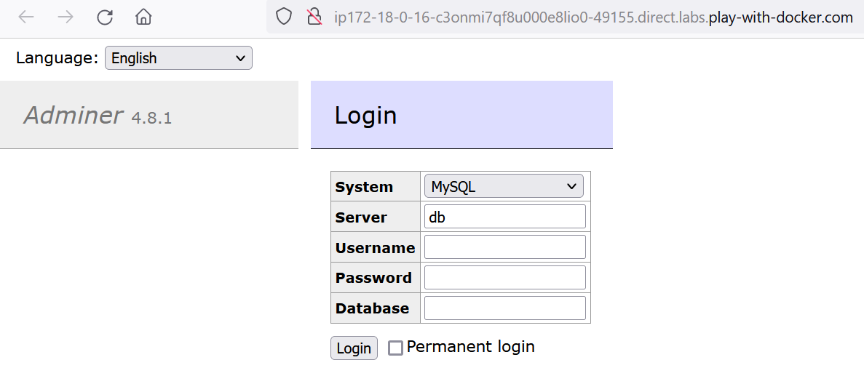





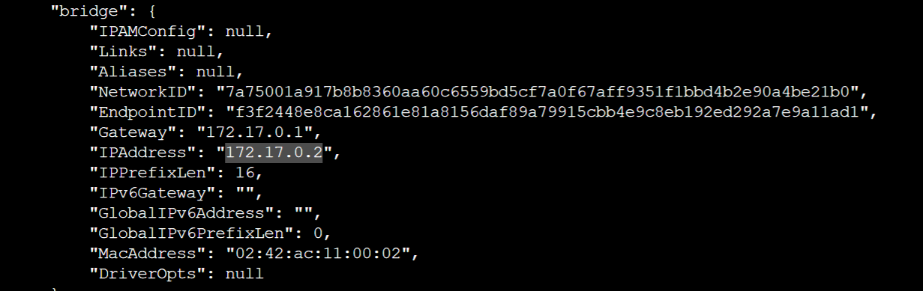

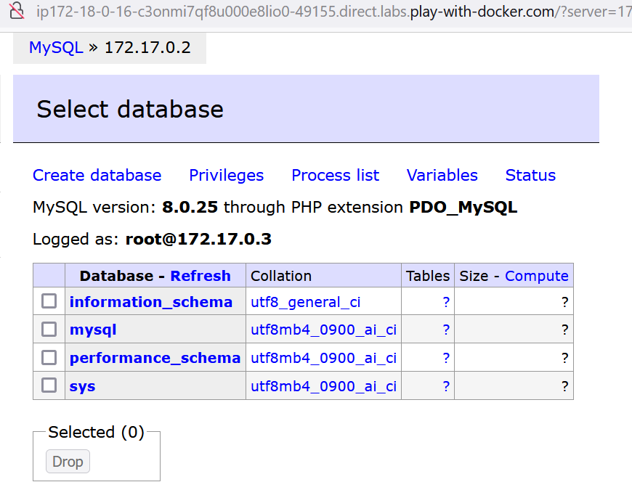

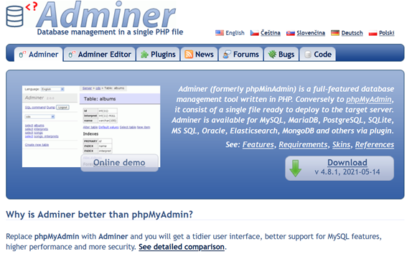

If mySQL pod goes down then we lost all data. For addressing this issue we have Kubernetes volume concept.

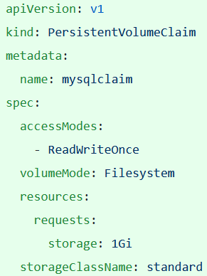

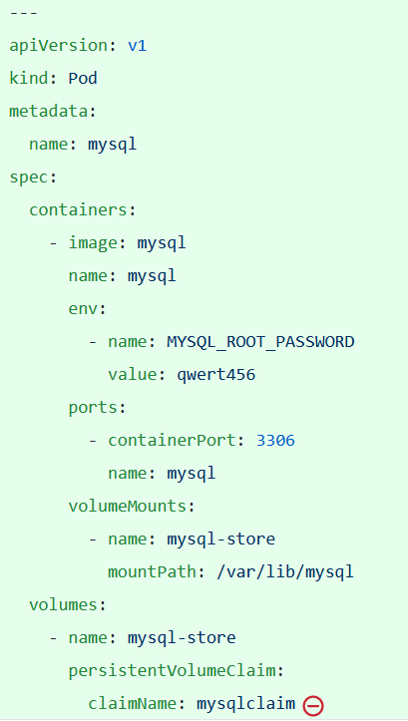

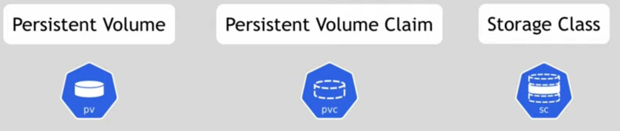

Let’s consider a scenario where we have microservice application running in K8s Environment. Application can perform CURD operation whereas there are chances that few Database admin activity would be done at DB side.

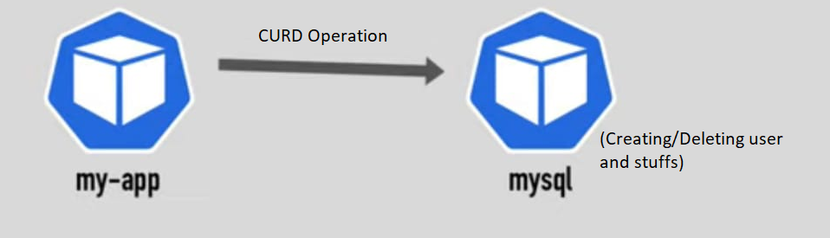

Let’s say database pod is down due to some issue, and we lost everything.

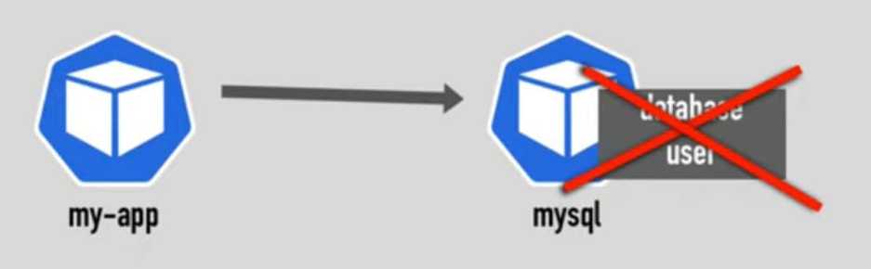

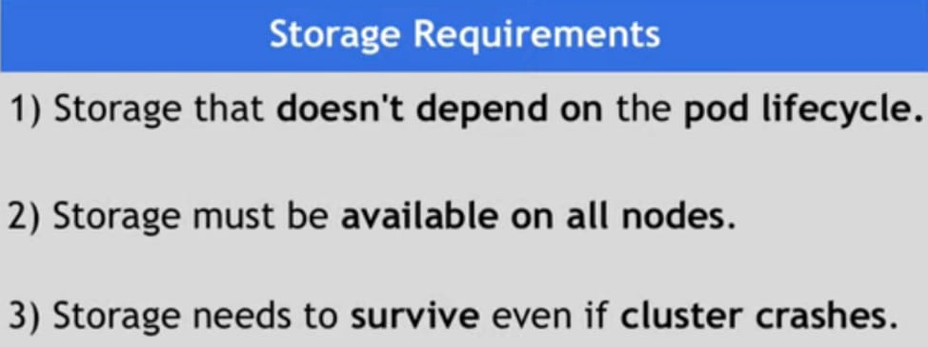

Note: We are not sure which pod may go down.

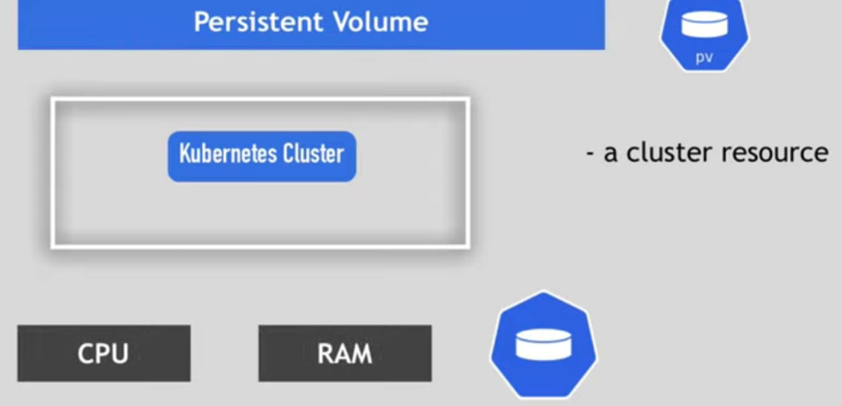

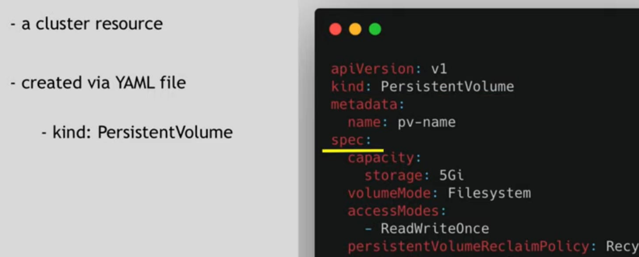

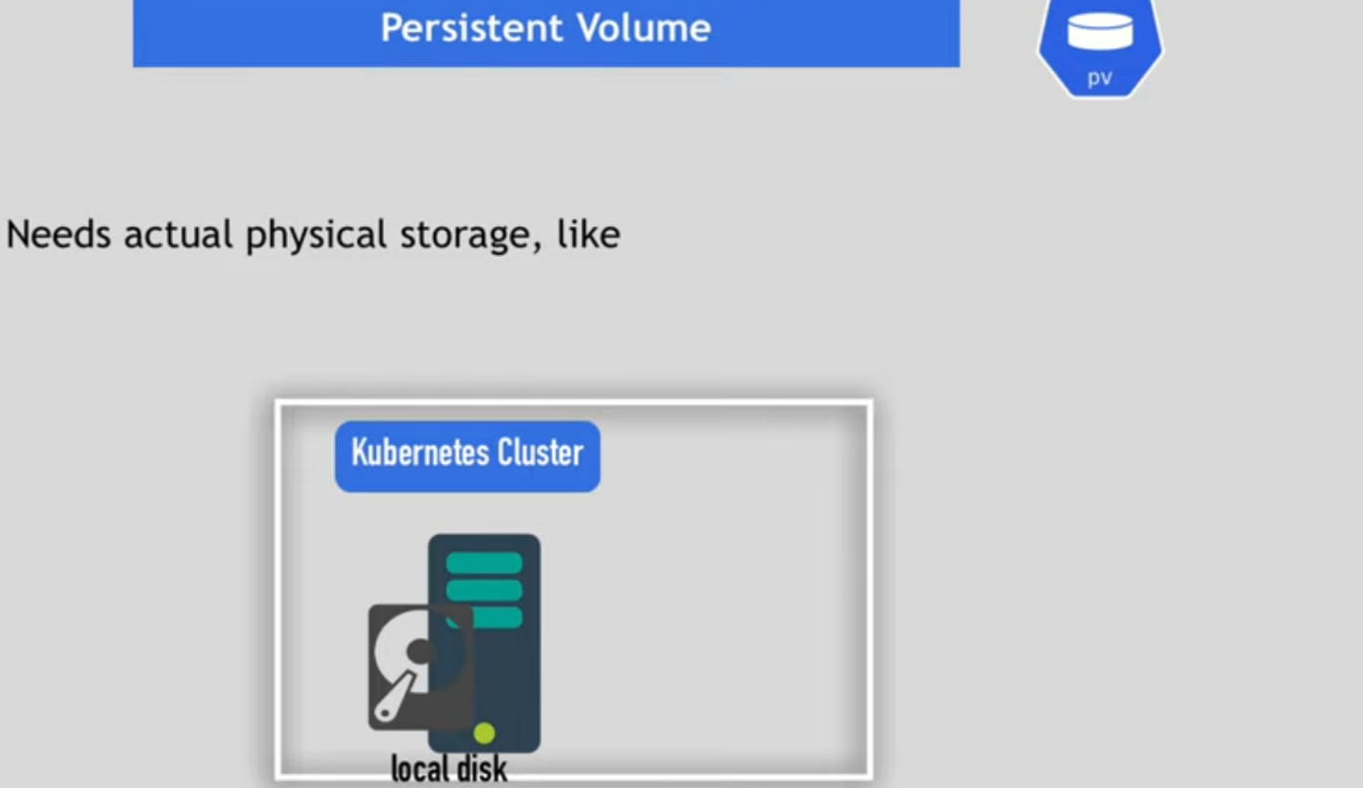

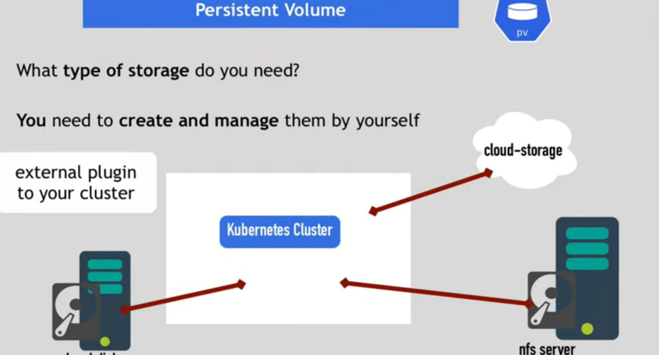

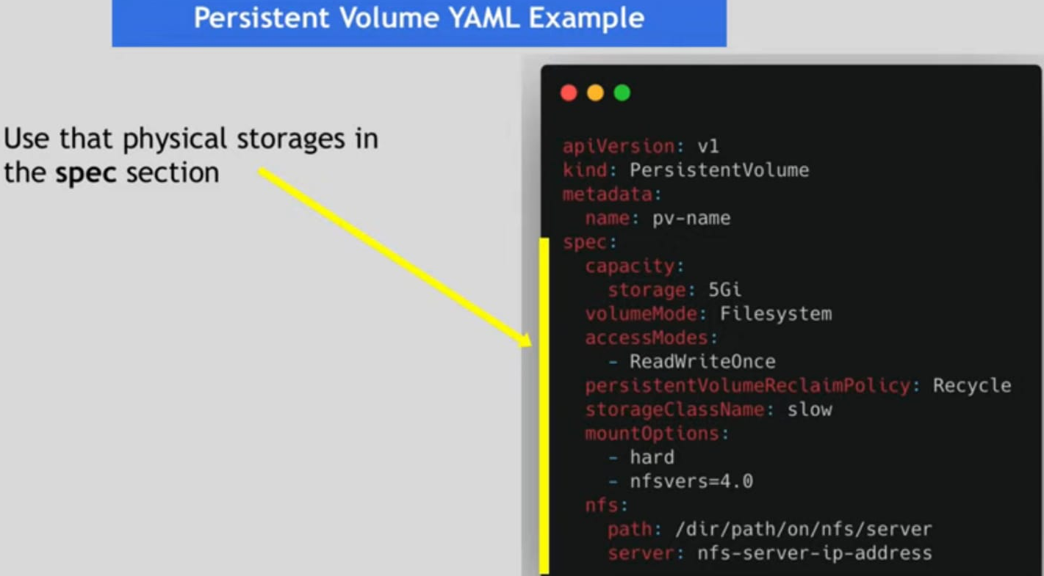

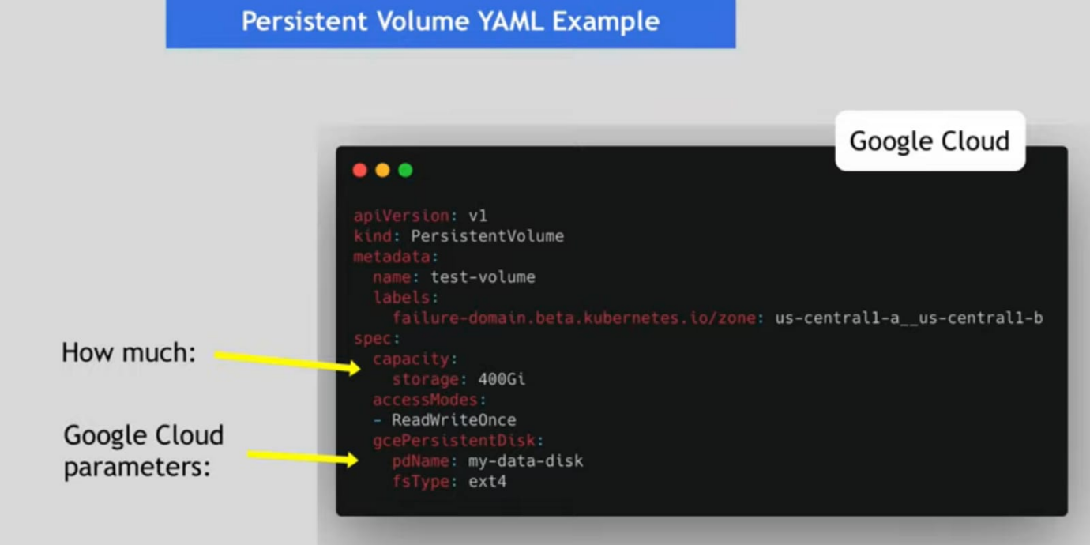

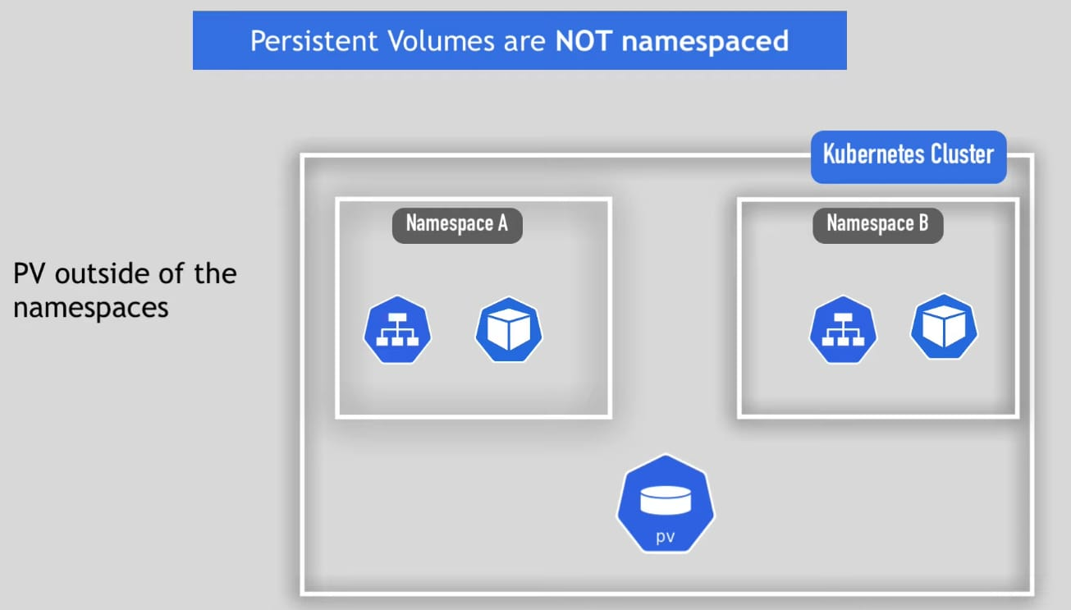

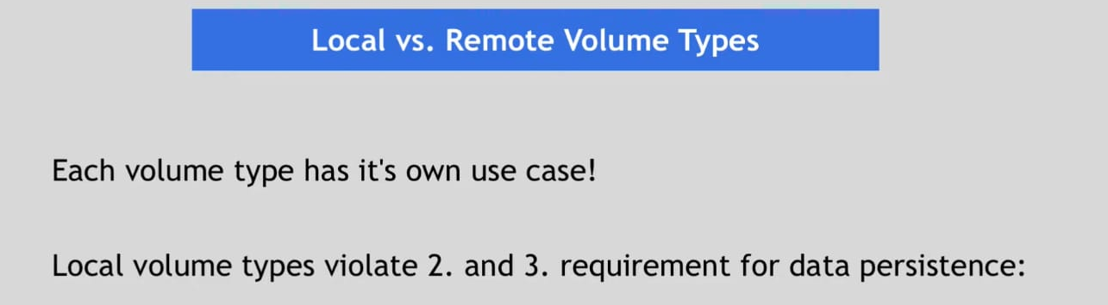

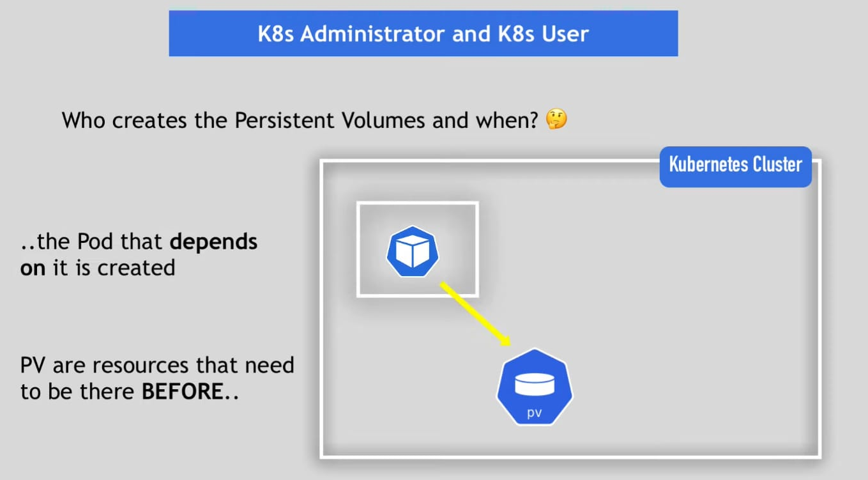

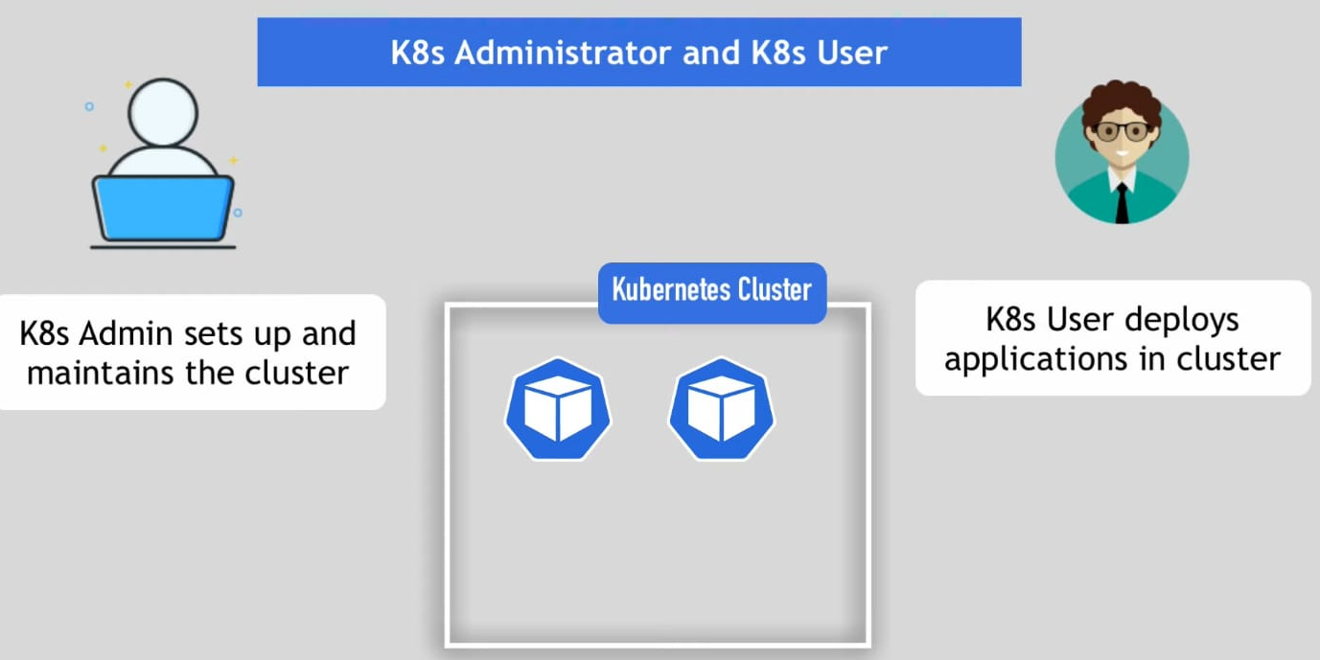

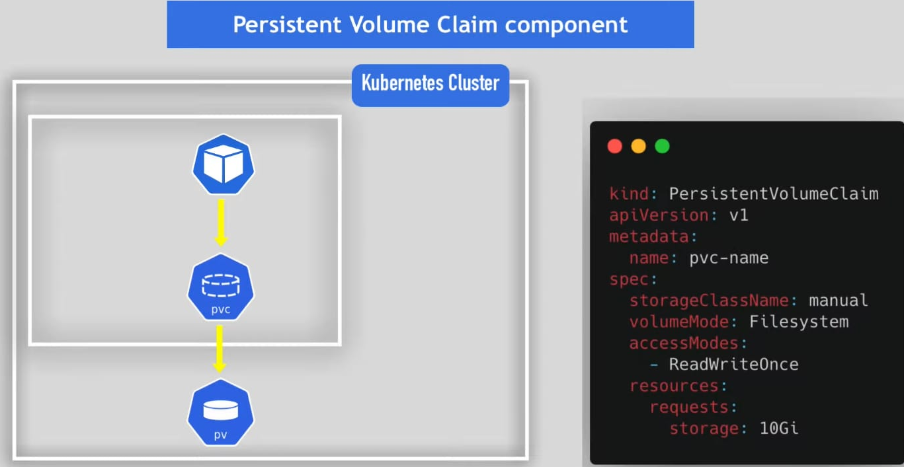

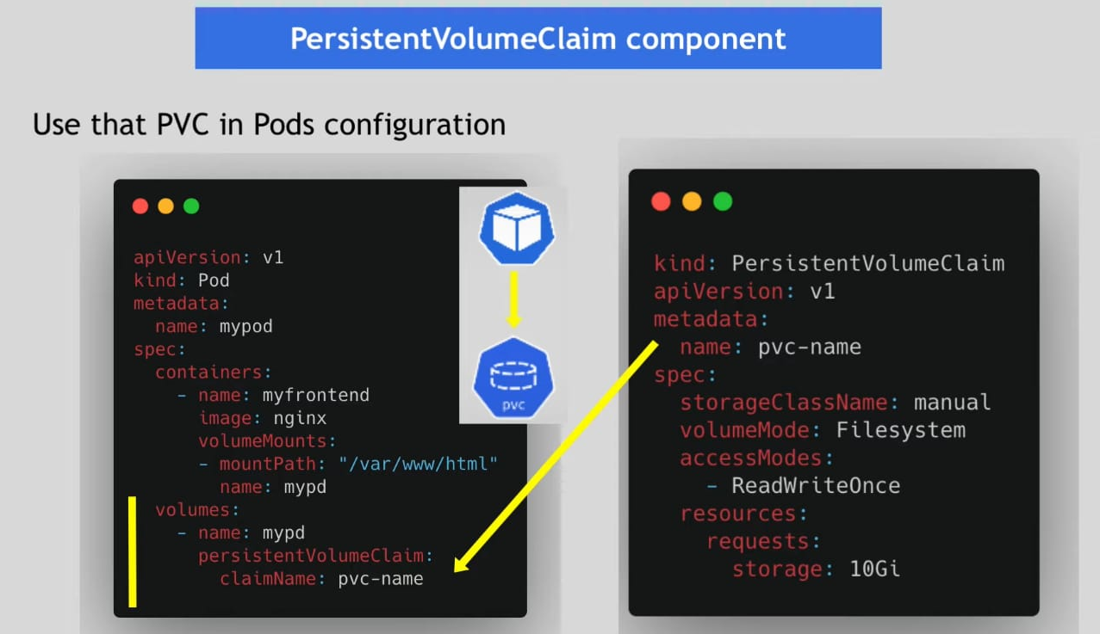

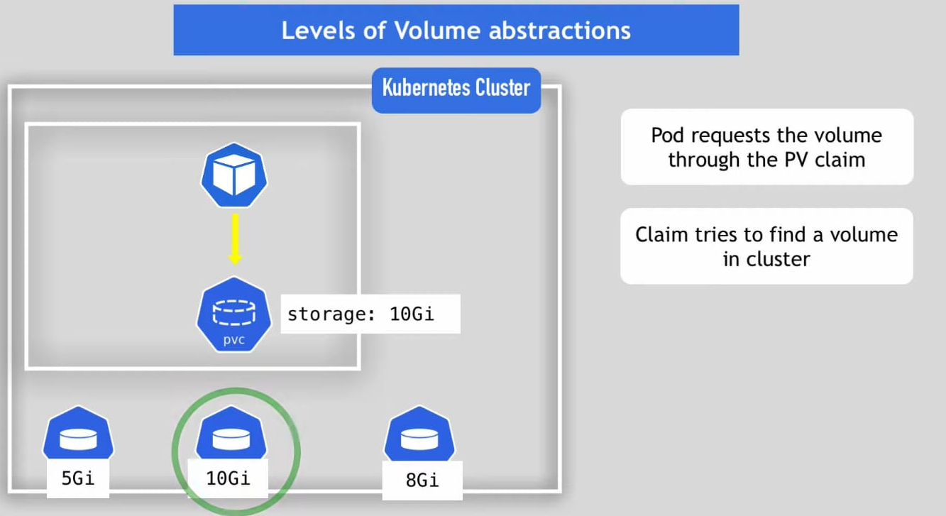

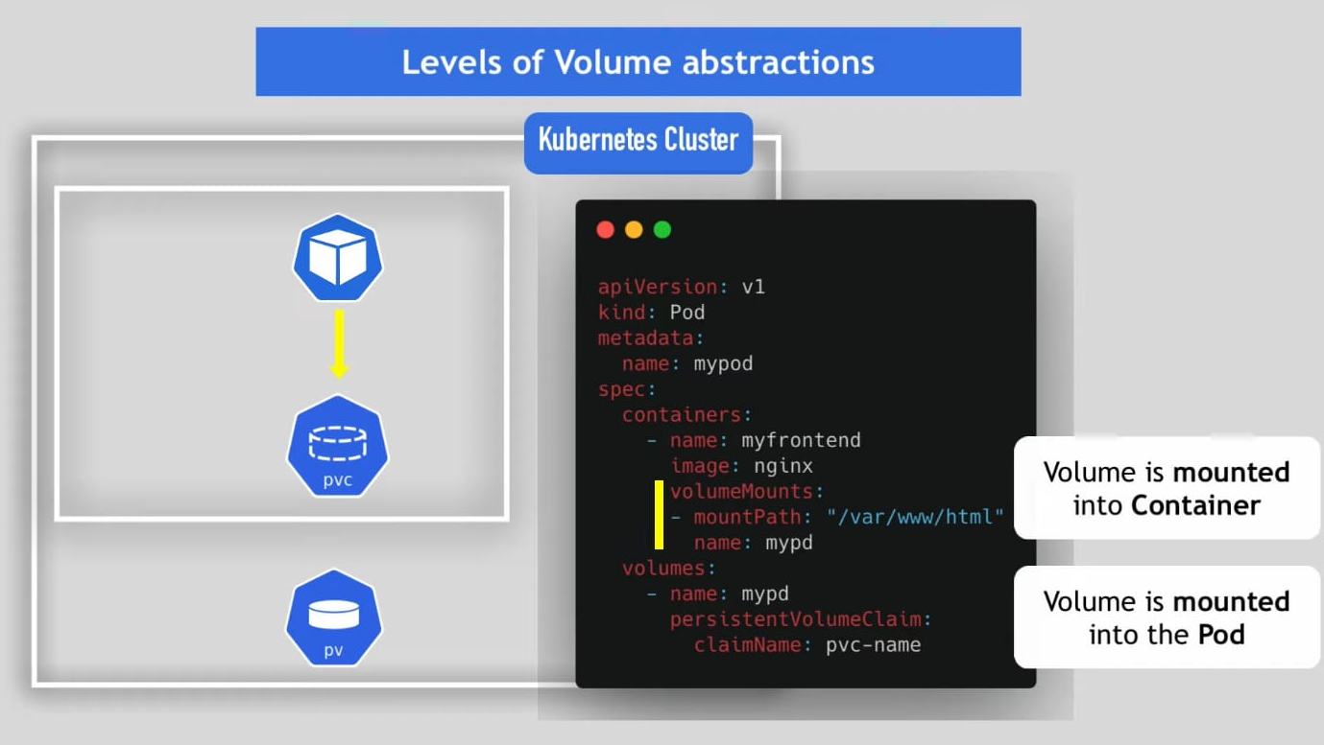

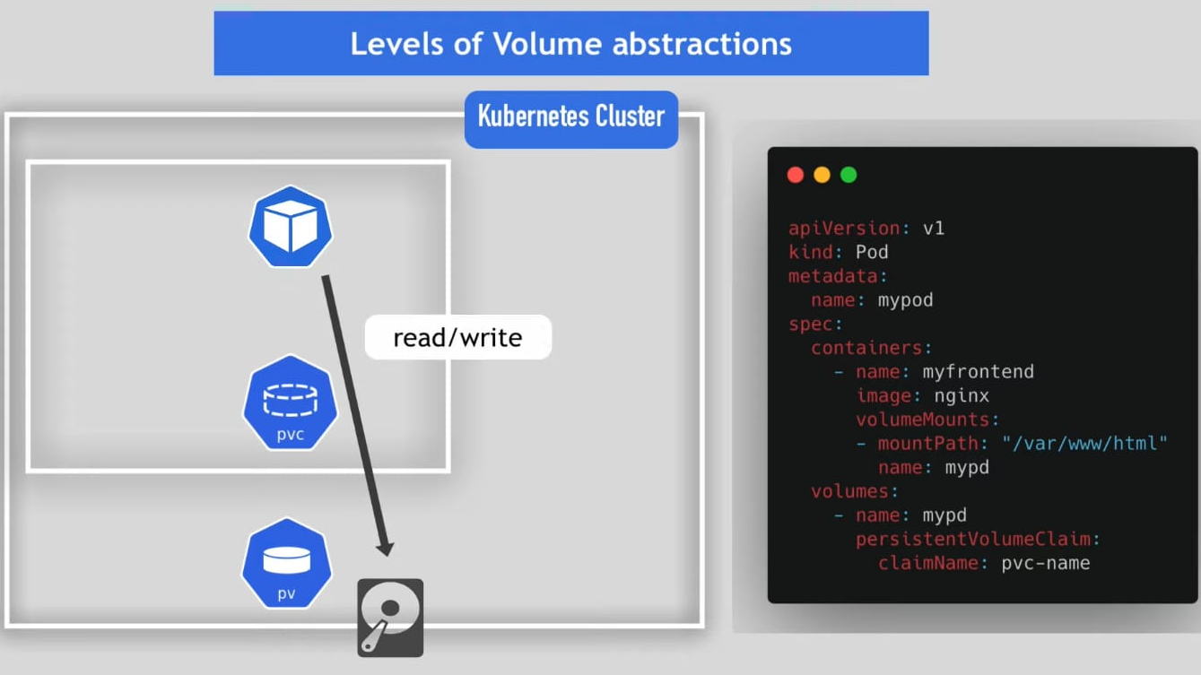

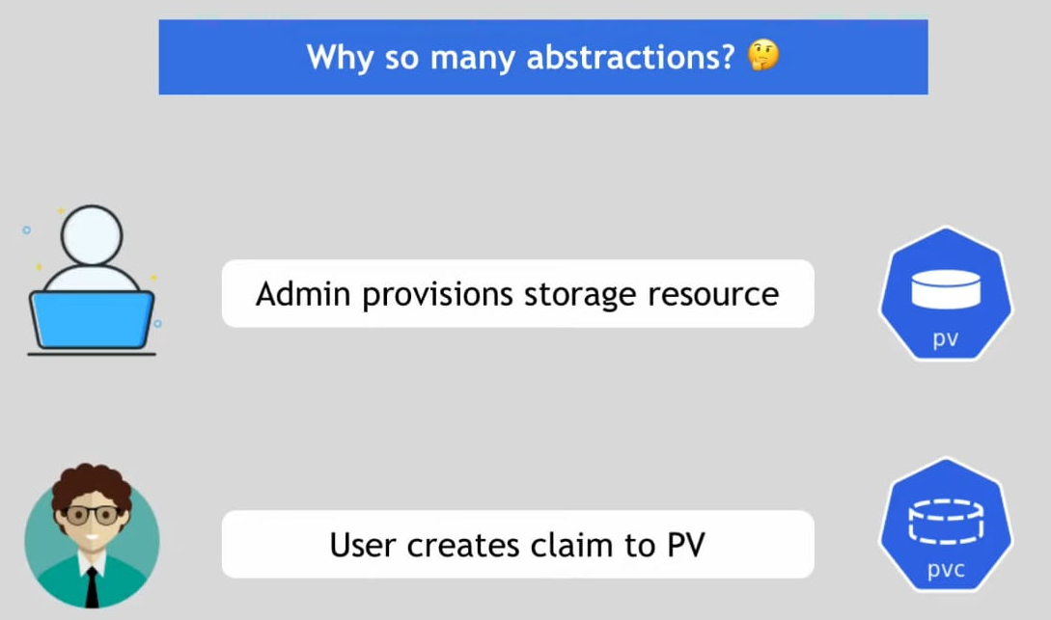

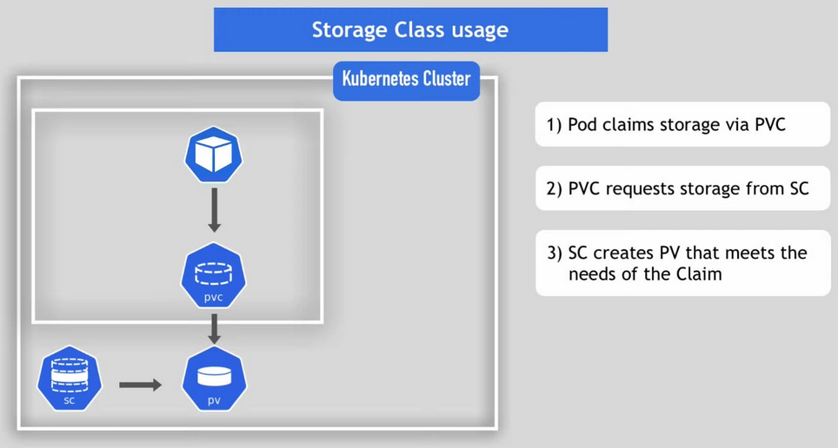

**ConfigMap and Secrete:**

